DMV Assignment 2 - Queries

Shayan - 27027

# Display all the order related information for the orders in 2013 and above.

**Select \***

**from OEHR_ORDERS**

**where year(cast(substring(Order_date, 1, 9) AS date)) >= '2013'**

OR

**Select \***

**from OEHR_ORDERS**

**where cast(substring(Order_date, 1, 9) AS date) >= '01-01-2013'**

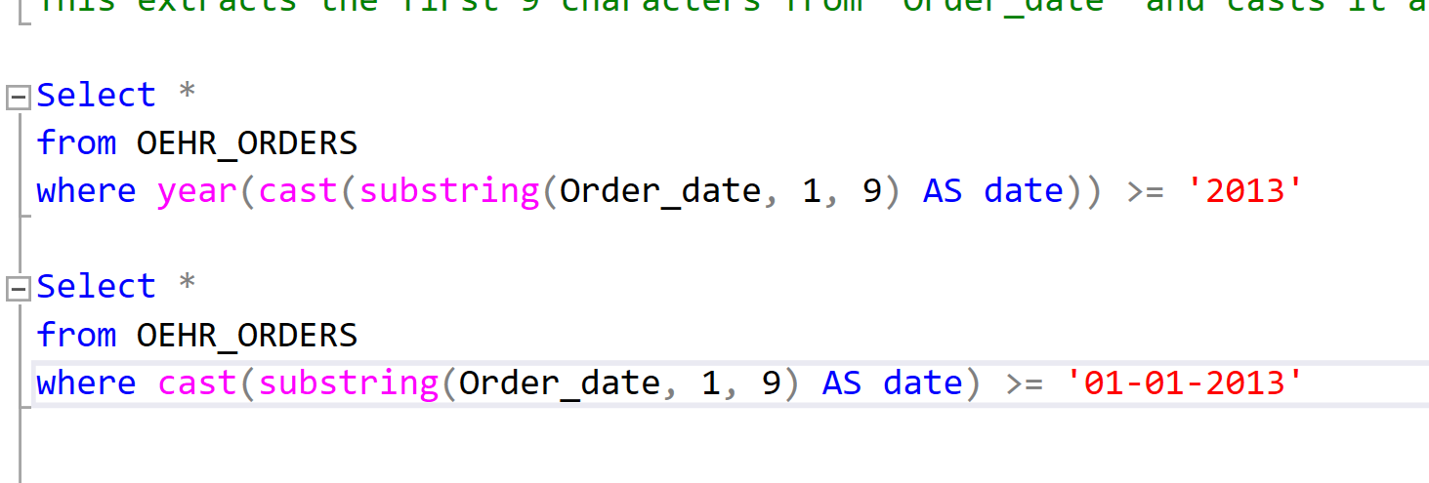

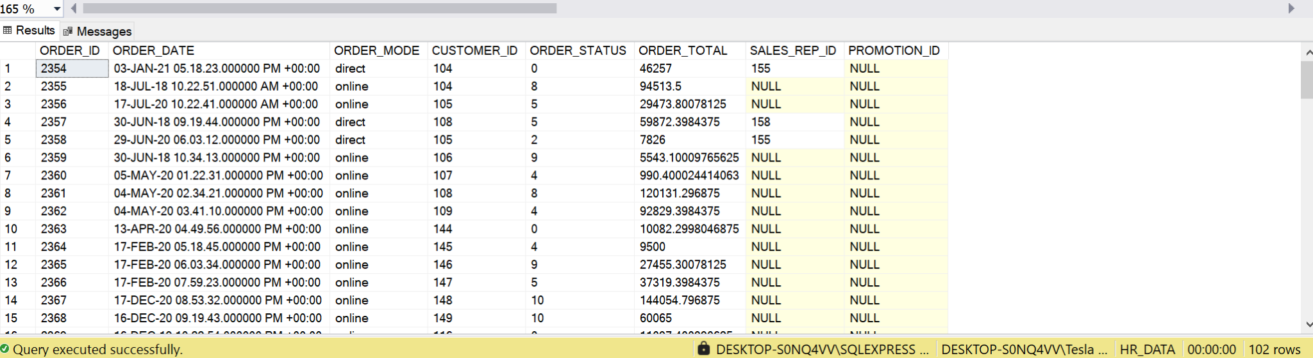

# Display the job history of all the employees from 2010 to 2015.

**select \***

**from OEHR_JOB_HISTORY**

**where (year(START_DATE) >= 2010 AND year(Start_DATE) <= 2015)**

**or**

**(year(END_DATE) >= 2010 AND year(END_DATE) <= 2015)**

***Other interpretation of this question***

**select * --- came after or in 2010 and ended before 2015**

**from OEHR_JOB_HISTORY**

**where year(START_DATE) >= 2010 AND year(END_DATE) < 2015**

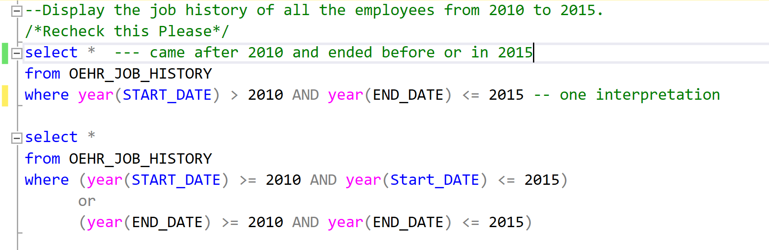

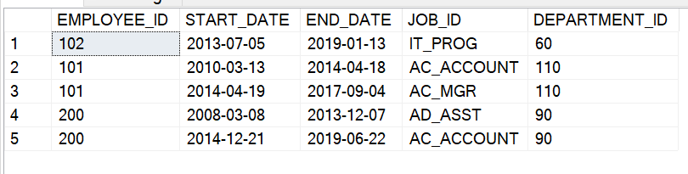

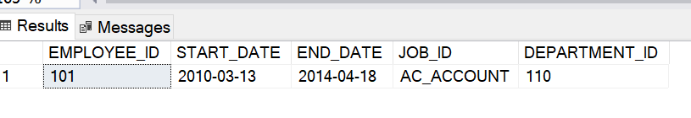

# Display all employee related information for employees whose firstname contains two "s" at any position. Two "s" may or may not be together, you have to show in both cases.

**select \***

**from OEHR_EMPLOYEES**

**where FIRST_NAME like '%s%s%' or FIRST_NAME like '%ss%'**

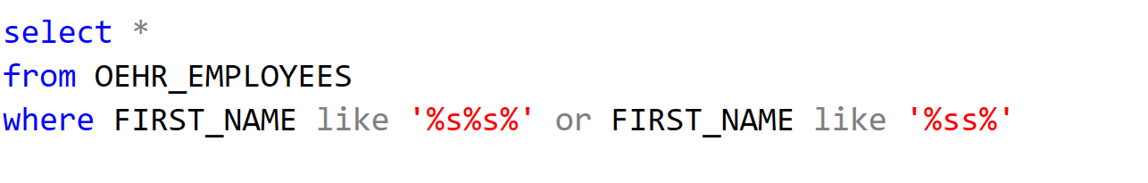

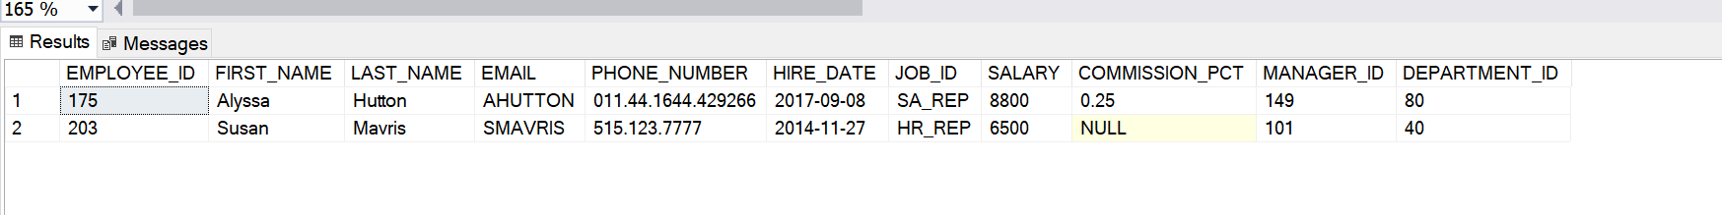

# Show only the employee with the lowest salary in department 90, within the salary range of 5000 to 30000.

**select Top 1 \***

**from OEHR_EMPLOYEES**

**where Salary between 5000 AND 30000 and DEPARTMENT_ID = '90'**

**order by salary**

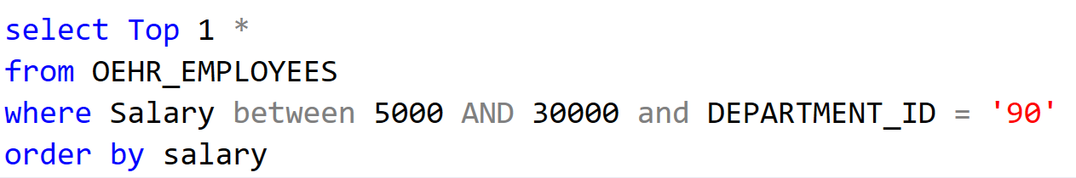



# Show All employees hired on the first of every month or on the third of every month, but not both.

**select \***

**from OEHR_EMPLOYEES**

**WHERE (DAY(HIRE_DATE)='01' AND DAY(HIRE_DATE) <> '03' ) or (DAY(HIRE_DATE) <>'01' AND DAY(HIRE_DATE) = '03')**

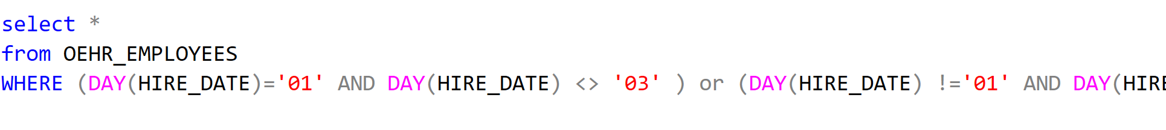



# Show all the customers that live in the city which name contains an "a" but not double "aa" together.

**select \***

**from OEHR_CUSTOMERS**

**where city like '%a%' and city not like '%aa%'**

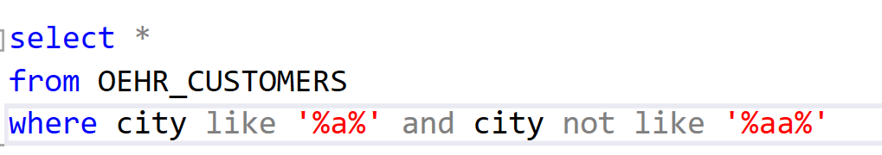

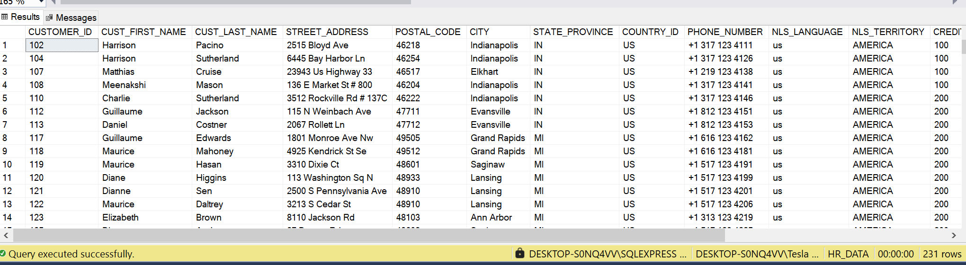

# Show all the customers who have not registered their email on Gmail.

**select \***

**from OEHR_CUSTOMERS**

**WHERE CUST_EMAIL Not LIKE '%gmail.com'**

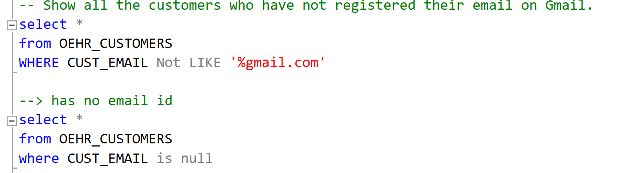

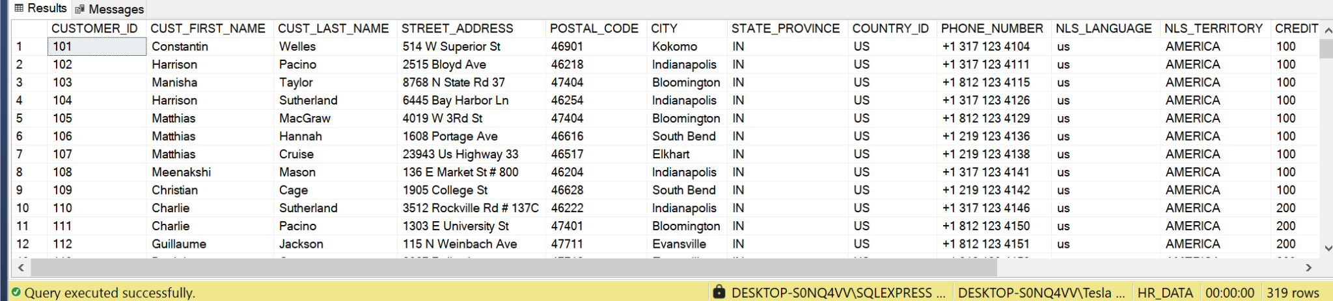

# Show All employees with salary greater than 10000 or department 90, but not both.

**select \***

**from OEHR_EMPLOYEES**

**where (Salary > 10000 AND DEPARTMENT_ID != '90' )**

**OR (salary <=10000 and DEPARTMENT_ID = '90')**

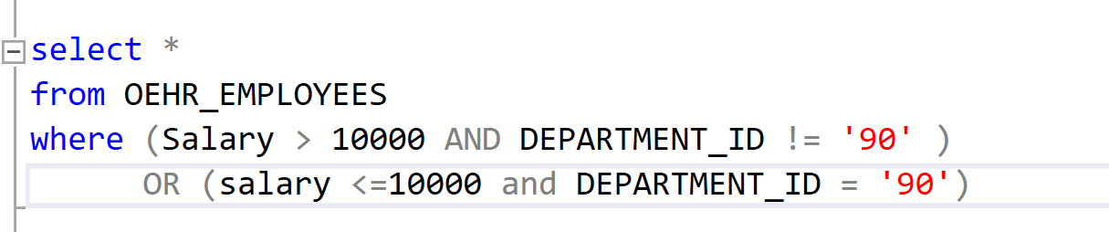

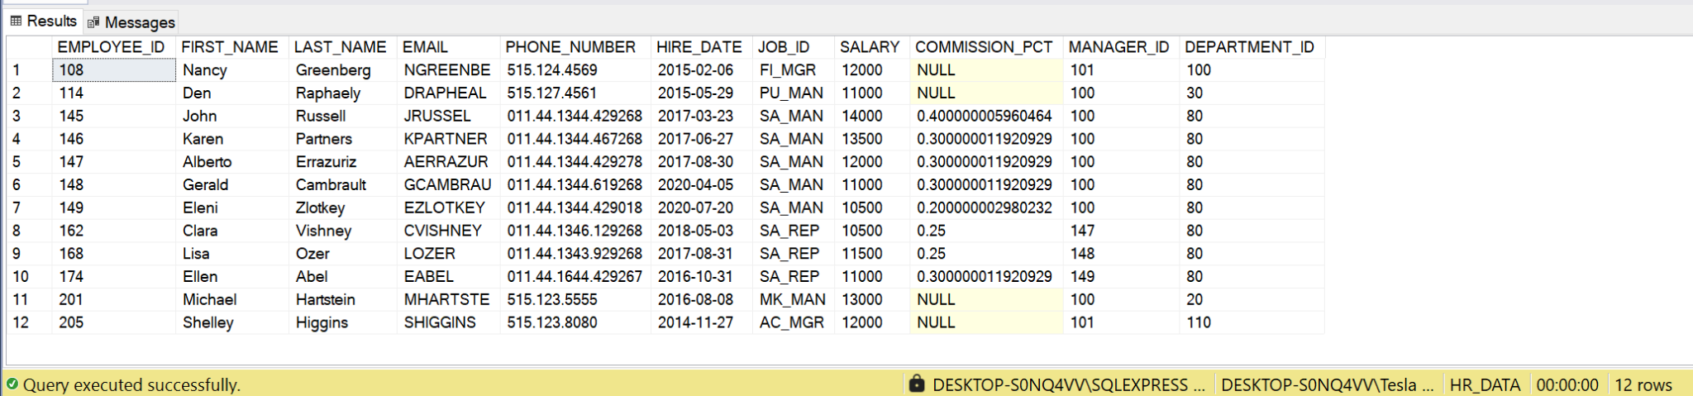

# Give me all the orders where order mode is "direct" and order status is 1, also display in the same query where order total is above 2000 regardless of the first condition.

**select \***

**from OEHR_ORDERS**

**where (ORDER_MODE = 'direct' and ORDER_STATUS = '1') OR (ORDER_TOTAL > 2000)**

